University of Washington — Bilkent University Summer Seminar

Digital Technology and Ottoman Textual Studies

Report
During the summer of 2006, The Ottoman Texts Archive Project (OTAP) with support and funding from the University of Washington Summer School, the Center for Digital Arts and Experimental Media (DXARTS), and the Department of Near Eastern Languages and Civilization and Bilkent University in Ankara, Turkey held a two week (June 26 – July 7) intensive seminar in Turkey on the application of digital technology to the study, analysis, and publication of Ottoman texts for professors and advanced graduate students. Held on the Bilkent University campus and originally limited to twenty participants, this unique program attracted such wide-spread interest in Turkey that Bilkent agreed to expand its offer of free housing and meals to thirty three attendees from seventeen different Turkish universities [see the Geographic Distribution Map below].
The seminar was a major success. Knowledgeable persons in Turkey had warned us that we would most likely lose at least half of our participants in the first few days. This did not happen. Two participants, who had misunderstood the nature of the seminar, dropped out on the first day and were immediately replaced by others from our waiting list. There were no further drop-outs. The group as a whole was eager, engaged, and willing to work long days and to attend voluntary lab sessions into the evening. One of the participants created a web site for the seminar (see “OTAP” at http://www.ilyasyazar.com) and a significant subset of the group indicated their eagerness to continue working with the OTAP project to contribute texts and to address issues raised during the sessions. The only disappointing aspect of the seminar was the lack of participants from the U.S. Several potential U.S. participants indicated that the combination of travel costs and out-of-state tuition made the seminar prohibitively expensive for them.
The Seminar
The seminar itself consisted of three major parts:
- Morning lectures, demonstrations, and lab sessions taught by Dr. Stacy Waters of DXARTS with the translation and technical assistance of NELC graduate student and OTAP associate, Didem Havlioglu and Bilkent assistants Sibel Kocaer, Sevim Kebeli, Emrah Pelvanoglu, and Tuba İsen Durmuş.
- An outstanding afternoon lecture series funded by Bilkent University, which brought to the campus the most respected and eminent Turkish experts on Ottoman texts and textual studies and several high officials from Turkish government offices and institutions responsible for supporting research on Turkish culture. This series was also attended by faculty from Bilkent and other Ankara area universities.
- Late afternoon lab sessions in which group members completed class exercises and projects under the supervision of Dr. Waters.
Daily Schedule:
8-9:30 Breakfast [provided by Bilkent]
9:40-12:30 Morning Session [Dr. Waters and assistants]
12:30-2:00 Lunch [provided by Bilkent] and break
2:00-4:00 Lecture Series [guest lecturers]
4:00-6:00 Afternoon Lab Session [Dr. Waters]
6:00-7:30 Dinner [provided by Bilkent]

1. The Technical Sessions
The Center for Digital Arts and Experiment Media (DXARTS/CARTAH) has provided active support for the Ottoman Text Archive Project (OTAP) since 1999 with technical expertise, consulting, and project management. The focus of these efforts has been to develop methods of producing and distributing electronic versions of Ottoman texts which adhere to open formats and encodings (ASCII and UNICODE), user community based standards for document content (XML and TEI), and the development of data handling methods using open source software (SED, PHP, MySQL, and XSLT) to create models for freely available web-based texts, dictionaries, and text analysis tools. The methods of text preparation developed and the technologies and tools adopted were those that could be freely acquired by Ottomanists and would require a moderate level of technical expertise only slightly more advanced than the ability to use web-browsers and word processors.
The goals of the narrowly technological aspect of the Bilkent University Seminar were:
- to familiarize scholars in Turkey with the practice of tagging texts;
- to demonstrate the uses of and differences between HTML and XML for humanities research;
- to introduce the use of non-proprietary software in preparing texts in open formats and encodings;
More broadly, however, the application of digital technologies to the humanities and, in particular, to Ottoman literature was the occasion for wide-ranging discussions of:
- document content and analysis for the development of tag sets;
- creation, presentation, and preservation of metadata;
- issues of alphabetic transcription and representation;
- electronic reproduction of variant forms of manuscript originals in dual alphabets;
- methods of textual analysis for digitized texts using software tools;
- copyright, intellectual property and web-based dissemination of texts;
- the role of technologies such as SED,CSS, and XSLT in the preservation of intellectual property and presentation of texts;
- optical character recognition of cursive scripts [Muammer Göçmen’s project];
- systems of machine translation between different alphabetic scripts [Mehmet Kara’s project];
- the presentation of electronic texts together with images of source documents.

2. The Lecture Series
The speakers and titles of their presentations:
- Dr. Mehmet Kalpaklı [Chair, Department of History, Bilkent University, Co-Director of OTAP]: The Ottoman Texts Archive Project (OTAP): Background and General Information.
- Prof. Halil İnalcık [Department of History, Bilkent University]: Hermeneutics: History and Texts.
- Prof. Özer Ergenç, [Department of History, Bilkent University]: Ottoman Documents and Document Analysis.
- Prof. Recep Toparlı [The Turkish Language Academy: Vice-Director and Head of the Historical Dictionary Project]: The Historical Dictionary Project.
- Prof. Atilla Şentürk [İstanbul University: Director of the Ottoman Text-Bank Project]: The Ottoman Text-Bank Project.
- Prof. İ. Hakkı Aksoyak [Gazi University, Ankara]: The Editing of Ottoman Texts.
- Dr. Cengiz Şişman, [TÜBİTAK (The Scientific and Technological Research Council of Turkey)]: General Information about Funded Research Projects in Turkey.
- Prof. Mustafa İsen [Undersecretary, The Ministry of Culture and Tourism]: Cultural Policies and Future Projects of the Turkish State.
- Prof. Ahmet Arı [Director of State Libraries and State Publications, Ministry of Culture and Tourism]: Goverment Publications and Manuscript Libraries in Turkey.
- Prof. Cem Dilçin [Ankara University]: Problems of Translating Ottoman Texts to Modern Turkish.
- Prof. Günay Kut [Boğaziçi University, İstanbul]: Editing Ottoman Texts.
- Dr. Gönül Alpay-Tekin [Harvard University, Editor of the Oriental Studies Series and director of the Cunda Ottoman Language School]: Text Editing and Literary Analysis.
- Prof. Walter G. Andrews [University of Washington, Co-Director of OTAP]: General Discussion: The Problems and Future of OTAP.
- Dr. Yücel Dağlı [Marmara University, İstanbul]: Archives, Databases, Ottoman Texts and Computing, Electronic Dictionaries.

The Future of OTAP

Based on discussions with seminar participants, visiting scholars, and government officials, the OTAP directors and staff decided that, in order to achieve its goals successfully, the project would need to do the following:

- Establish a board of experts who would review submissions of texts for web-publication.
- Establish links with a press or journal for print publication of refereed submissions. [Until such time as #3 is accomplished.]
- Explore with responsible academic organizations in Turkey (e. g. YÖK) the possibility (or necessity) of considering refereed web publications of texts and accompanying digitized manuscripts as equivalent to print publications for purposes of promotion and tenure.
- Relocate the main web-site for OTAP to a Turkish government server (TÜBİTAK?).
- Seek support (e.g. UNESCO) and Turkish funding for individual contributors and web-based text edition and analysis centers at participating Turkish universities. [For example: government funding such as TÜBİTAK, KTB; private funding sources, banks, foundations, etc.].

It is the belief of the directors, reinforced by our experiences in the seminar, that OTAP should not lose its international character but that it should be primarily a Turkish project with its heart in Turkey. This means that the basic financial and logistical support for the project should come from Turkish sources, which would accurately reflect the fact that the vast majority of the submissions to the project will inevitably come from Turkish scholars and that the major contributions of the project will be to the study and dissemination of Turkish culture.
- Addenda

OTAP Seminar Participants University Affiliation

1. Doç. Dr. Mehmet Kara Fatih University, Istanbul: Turkish Language and Literature Department.
2. Doç. Dr. Nesrin Karaca Başkent University, Ankara: Turkish Language and Literature Department.
3. Yrd. Doç. Dr. Muammer Göçmen Süleyman Demirel University, Isparta: Religion Faculty, Islamic History and Arts Department.
4. Yrd. Doç. Dr. Orhan Kemal Tavukçu Atatürk University, Erzurum: Turkish Language and Literature Department.
5. Yrd. Doç. Dr. İsmail Güleç Sakarya University, Sakarya: Turkish Education Department.
6. Yrd. Doç. Dr. Rıza Oğraş Süleyman Demirel University, Isparta: Burdur Education Faculty, Turkish Education Department.
7. Yrd. Doç. Dr. Ömer Savran Harran University, Urfa: Turkish Language and Literature Department.
8. Yrd. Doç. Dr. Turhan Kaya Atatürk University, Erzurum: Turkish Language and Literature Department.
9. Ayfer Aytaç Çanakkale Onsekiz Mart University, Çanakkale: Turkish Language and Literature Department.
10. Osman Ünlü Ege University, Izmir.
11. İlyas Yazar Dokuz Eylül University, İzmir: Buca Education Faculty, Turkish Language and Literature Department.
12. Ekrem Bektaş Harran University, Urfa: Turkish Language and Literature Department.
13. Tuncay Böler Ankara University, Ankara
14. Hasan Gültekin Hacettepe University, Ankara
15. Ersin Terez Yıldız Technical University, Istanbul: Turkish Language and Literature Department
16. Nesrin Yalçın Dokuz Eylül University, İzmir: Religion Faculty.
17. Eflak Malgaca Dokuz Eylül University, İzmir: Turkish Language and Literature Department
18. Hadi Sofuoğlu Dokuz Eylül University, İzmir: Religion Faculty.
19. Meryem İdiler Boğaziçi University, Istanbul.
20. Berat Açıl Boğaziçi University, Istanbul: Turkish Language and Literature Department.
21. Halil İbrahim İskender Boğaziçi University, Istanbul.
22. Cengiz Veli Kurmuş Çukurova University, Adana: Turkish Language and Literature Department
23. Döndü Akarca Çukurova University, Adana.
24. Ayşe Yıldız Gazi University, Ankara: Turkish Language and Literature Department.
25. İsrafil Babacan Gazi University, Ankara: Turkish Language and Literature Department.
26. Neslihan Koç Keskin Gazi University, Ankara: Turkish Language and Literature Department.
27. Emine Tuğcu Bilkent University, Ankara: Turkish Literature Department.
28. Tuba İsen Durmuş [Assistant] Bilkent University, Ankara: Turkish Literature Department.
29. Sibel Kocaer [Assistant] Bilkent University, Ankara: Turkish
Literature Department.
30. Bahadır Sürelli Bilkent University, Ankara: Turkish
Literature Department.
31. Sevim Kebeli [Assistant] Bilkent University, Ankara: Turkish
Literature Department.
32. Emrah Pelvanoğlu [Assistant] Bilkent University, Ankara: Turkish
Literature Department.
33. Murat Umut İnan Boğaziçi University, Istanbul: Turkish Language and Literature Department.

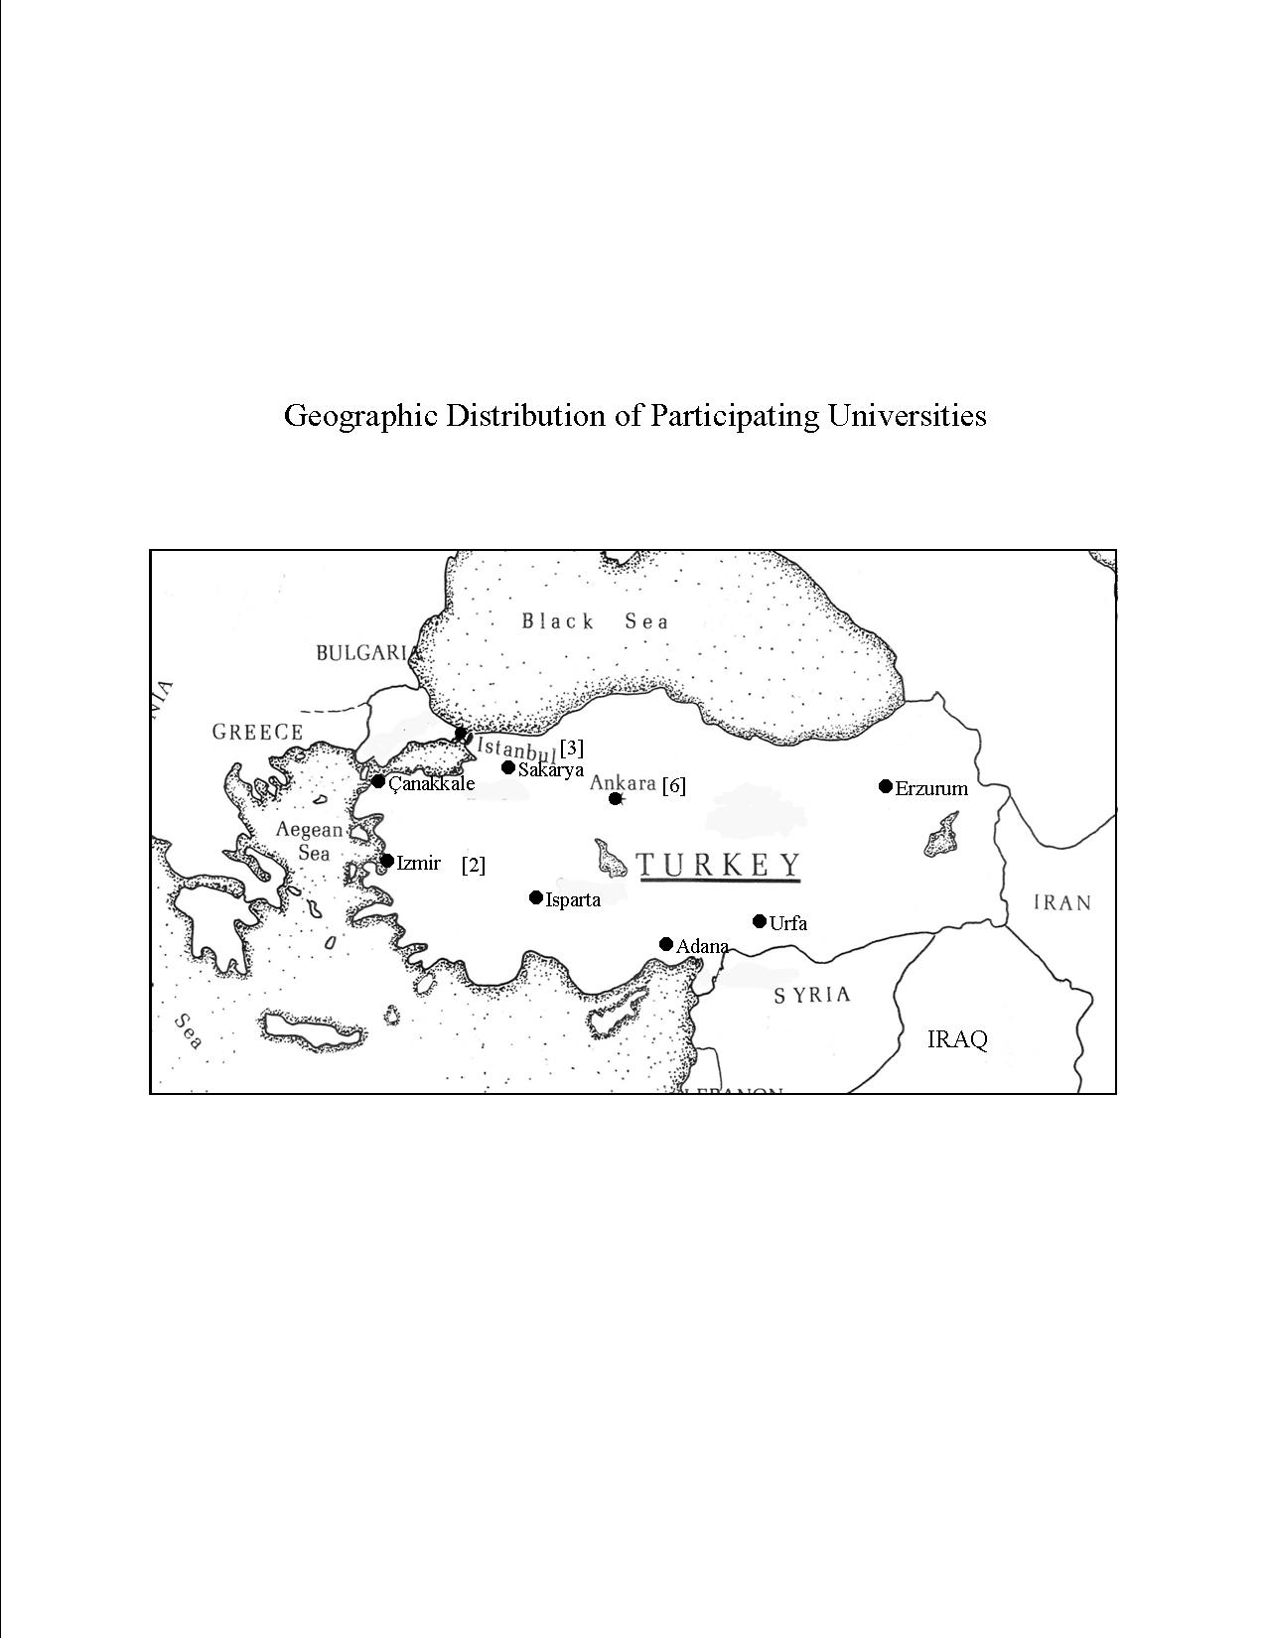
Statistical Profile of Seminar Participants:

University Position:

Associate Prof. 1

Assistant Prof. 5

Graduate Student 27

Academic Specialty [department, program]:

Turkish Language and Literature: 22

Religious Studies: 2

Turkish Language and Linguistics: 2

Library: 1

Unknown: 5

Gender:

Female 11

Male 22

Geographic Distribution:

Metropolis [Istanbul, Ankara]: 16

Regional: 17

East: 4

West: 11

Central: 17

